**ChatGPT Reviews Analysis**

The dataset contains 196,727 user reviews of ChatGPT with the following columns:

* Review Id (unique identifier)

* Review (text, some missing values)

* Ratings (1 to 5)

* Review Date

Now, I'll analyse this data to generate 5 key insights.

Here are 5 key insights from the dataset:

**1. Highly Positive Reviews:**

The majority of users rated ChatGPT very positively — 76% of all reviews are 5 stars (150,215 out of 196,727)**.

**2. Average User Rating:**

The overall average rating is 4.50 out of 5, indicating strong user satisfaction.

**3. Minimal Missing Data:**

Only 6 reviews are missing textual content, so the dataset is nearly complete in terms of review text.

**4. Most Active Month:**

The highest number of reviews were submitted in May 2024, with 28,325 reviews in that month alone.

**5. Rating Distribution:**

Aside from the 5-star ratings, the next most common rating is 4 stars (22,897 reviews). Only about 6% of reviews are 1-star, suggesting relatively low dissatisfaction.

Here are the results of the sentiment analysis:

**### Sentiment Breakdown:**

* Positive: 145,607 reviews (~74%)

* Neutral: 44,620 reviews (~23%)

* Negative: 6,143 reviews (~3%)

**### Most Positive Reviews:**

1. "Excellent resource for teachers, and it would also apply in every day life for anyone."

2. "it's awesome. just try it."

3. "the best app ever ❤️❤️❤️❤️"

**### Most Negative Reviews:**

1. "Disgusting"

2. "insane"

3. "This app is very bad!"

Here are two-word clouds showing the top keywords in user reviews:

**Positive Reviews:** Common words include “amazing,” “helpful,” “love,” “great,” and “useful,” reflecting appreciation for ChatGPT’s capabilities and support.

**Negative Reviews:** Frequent terms like “bad,” “useless,” “worst,” “crashes,” and “ads” suggest frustration with functionality, performance, or intrusive experiences.

Here are the **5 main topics** discovered from the reviews using topic modelling, each summarized by their top keywords:

**Topic 1: General Use and Functionality**

* Keywords: *good, app, application, experience, ai, apps, really, work, pretty, aap*

🗣 Users frequently mention the overall performance and reliability of the app.

**Topic 2: Satisfaction and First Impressions**

* Keywords: *nice, app, application, work, ai, aap, wow, experience, apps, chat*

💬 Focuses on users describing their first experience with excitement and satisfaction.

**Topic 3: Enthusiastic Praise**

* Keywords: *best, ai, app, world, friend, application, chatgpt, chat, seen, used*

🏆 Strong endorsement of ChatGPT as the best app or AI tool they've used.

**Topic 4: Love and Utility**

* Keywords: *app, great, love, amazing, useful, excellent, like, awesome, really, use*

❤️ Emphasizes affection for the app, often describing it as both enjoyable and practical.

**Topic 5: Educational and Support Use**

* Keywords: *helpful, really, students, chatgpt, amazing, application, love, thank, use, like*

📚 Highlights ChatGPT’s role in education and productivity, especially for students.

The chart above shows how interest in each topic has changed over time. Here's a quick interpretation:

* **Topic 0 (General Use)** and **Topic 3 (Love & Utility)** consistently dominate, indicating steady appreciation for the app’s usefulness and overall quality.
* **Topic 4 (Education/Helpfulness)** shows a rise in some months—possibly aligned with school terms or exam seasons.
* **Topic 2 (Best AI Ever)** had a brief surge, suggesting spikes in strong praise, perhaps after feature updates.
* **Topic 1 (First Impressions)** remains relatively stable, likely reflecting a consistent flow of new users.

The most common themes in **negative reviews** focus on frustration and unmet expectations. Here are the top keywords and what they likely point to:

**🔧 Functionality Issues**

* **"app", "work", "login", "use"** — Many users complain about the app not functioning properly or being difficult to use or access.
* **"doesn", "don"** — Likely fragments of complaints like "doesn't work" or "don't like."

**❌ Low-Quality Responses**

* **"wrong", "answers", "answer", "information"** — Indicates dissatisfaction with the quality or correctness of ChatGPT's responses.

**😠 Negative Sentiment Words**

* **"bad", "useless"** — Direct expressions of disappointment or dissatisfaction.
* **"just", "like", "good"** — Often used sarcastically or in negative comparisons (e.g., "not just bad," "not like it used to be").

**🤖 AI-Specific Criticism**

* **"ai", "chatgpt", "gpt", "chat"** — While expected their presence in negative reviews suggests the criticism is directed specifically at the AI's performance.

The chart above shows how the number of **negative reviews** has changed over time:

* There are **occasional spikes** in negative feedback, suggesting periods of user dissatisfaction — possibly due to bugs, app changes, or downtime.
* Overall, the trend appears relatively **stable** with **moderate fluctuations**, not a dramatic increase or decrease.

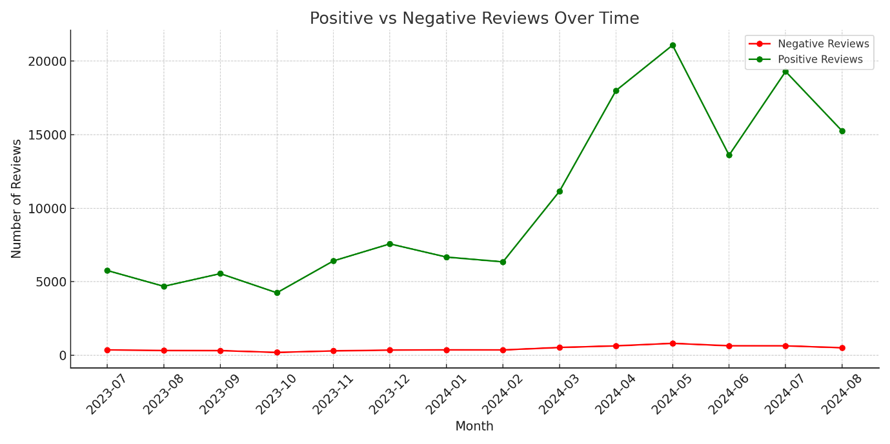

The chart compares **positive** (green) and **negative** (red) reviews over time:

* 📈 **Positive reviews consistently outnumber negative ones** by a wide margin each month.
* 🔺 **Spikes in negative reviews** often occur alongside increases in positive reviews, suggesting those months had higher overall usage or visibility (e.g. updates, promotions).
* 🧩 In some months, the **gap narrows slightly**, possibly indicating issues or controversial changes that triggered more complaints.

The chart shows how **review sentiment evolved over time**:

**📊 Observations:**

* **Positive sentiment** consistently dominates, holding around **70–80%** of monthly reviews.
* **Negative sentiment** remains low but shows **occasional increases** (notably in **June 2024**), often aligned with technical issues or app updates.
* **Neutral sentiment** hovers steadily, suggesting a stable baseline of lukewarm or mixed user feedback.

This view can help identify months that need further investigation due to dips in satisfaction.

**ChatGPT Review Insights (196K+ reviews):**

* **Average Rating**: 4.5 ⭐
* **Sentiment**: 74% Positive, 23% Neutral, 3% Negative
* **Most Active Month**: May 2024 (28K reviews)

**Top Complaints (Negative Reviews):**

* Keywords: *bad, useless, wrong, login, doesn’t work*
* Issues: App bugs, login problems, inaccurate answers, update glitches

**Main Review Topics:**

1. General use & performance
2. First impressions
3. Praise: “Best AI app”
4. Love & utility
5. Helpful for students

**Trend Highlights:**

* Negative review spikes: May–July 2024
* Ratings mostly stable; dips align with complaints or updates